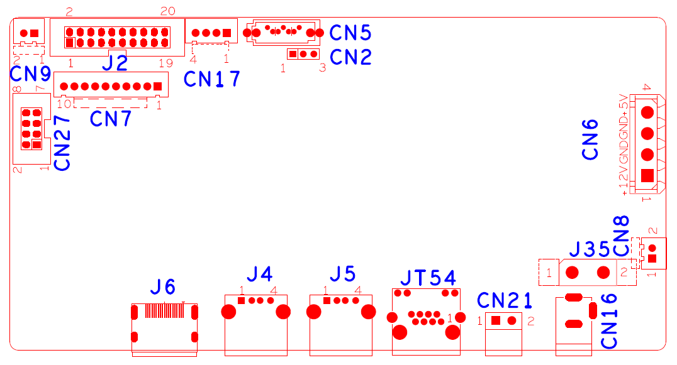

 | Function Description | Definition
CN27 | Alarm input and output expansion pedestal | 1:ALIN4 | 2：ALOUT1 | 3：ALIN2 | 4：ALIN3
 |  | 5：GND | 6：ALIN1 | 7：+5 | 8：GND
CN9 | Fan power pedestal | 1：+12 | 2：GND
J2 | 20PIN front panel pedestal | 1：GND | 2: ROW0 | 3: ROW4 | 4: COL4
 |  | 5: ROW3 | 6: COL0 | 7: COL2 | 8: ROW1
 |  | 9: COL1 | 10: ALARM | 11: REC | 12: IR
 |  | 13: LINK | 14: +3.3 | 15: COL3 | 16: ROW2
 |  | 17:NC | 18:GND | 19：NC | 20:NC
CN7 | 10PIN Without SCM front panel pedestal | 1:+3.3 | 2：GND | 3：IR | 4：COL2
 |  | 5：COL1 | 6：ROW2 | 7：COL3 | 8：ROW1
 |  | 9：ALARM | 10：REC
CN17 | USB Expand pedestal | 1：+5 | 2：USB2DM | 3：USB2DP | 4：GND
CN5 | SATA Interface pedestal
CN2 | RS232 serial port
CN6 | Hard disk power pedestal | 1：+12 | 2：GND | 3:GND | 4:+5
CN8 | Fun Power pedestal | 1：+12 | 2：GND
CN16 | 12V Power input interface
J35 | 12V Power switch pedestal
CN21 | RS485 serial port
JT54 | RJ45 network interface
J5 | USB interface
J4 | USB interface
J6 | HDMI interface

