X3IM-H200NS interface
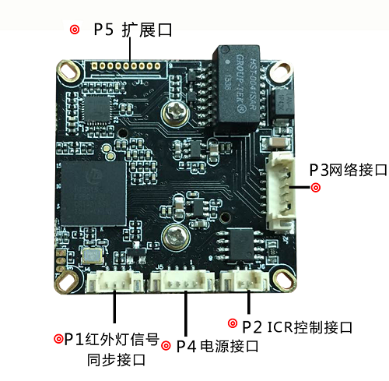
PIN plug | logo | Pin # | Pin function
P1 | J4 | 1 | IR-CUT input
P1 | J4 | 2 | GND
P1 | J4 | 3 | NC
P2 | J6 | 1 | IR-CUT
P2 | J6 | 2 | IR-CUT
P3 | J2 | 1 | ETHRX-
P3 | J2 | 2 | ETHRX+
P3 | J2 | 3 | LEDLINKA
P3 | J2 | 4 | ETHTX-
P3 | J2 | 5 | ETHTX+
P3 | J2 | 6 | NET_LED_ACT
P4 | J5 | 1 | NON
P4 | J5 | 2 | NON
P4 | J5 | 3 | GND
P4 | J5 | 4 | +12V_IN
P5 | J1 | 1 | GND
P5 | J1 | 2 | USB_DP
P5 | J1 | 3 | USB_DM
P5 | J1 | 4 | +5V
P5 | J1 | 5 | AC_OUT
P5 | J1 | 6 | MIC_P
P5 | J1 | 7 | NC
P5 | J1 | 8 | AGND
P5 | J1 | 9 | ALARM_IN

