X3IM-HS20M-S Interface
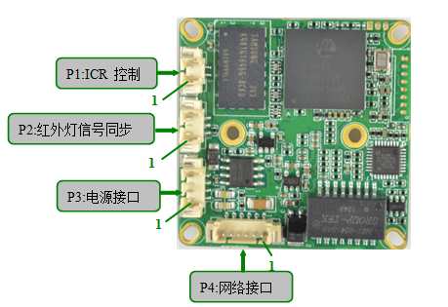

Pin plug | logo | Pin # | Pin function
P1 | J6 | 1 | ICR
P1 | J6 | 2 | ICR
P2 | J7 | 1 | ICR input
P2 | J7 | 2 | GND
P2 | J7 | 3 | NC
P3 | J3 | 1 | +48
P3 | J3 | 2 | +48_GND
P3 | J3 | 3 | GND
P3 | J3 | 4 | +12V_IN
P4 | J1 | 1 | ETHRX-
P4 | J1 | 2 | ETHRX+
P4 | J1 | 3 | LEDLINKA
P4 | J1 | 4 | ETHTX-
P4 | J1 | 5 | ETHTX+
P4 | J1 | 6 | NET_LED_ACT

